Assignment 01



|  |  |
| --- | --- |
| Submitted to: | Ma’am Yasmeen |
| Submitted by: | Muhammad Zamar |
| Registration no: | SP22-BCS-061 |
| Section: | A |

Department of Computer Science

COMSATS University Vehari Campus.

**Program 1**

#include <iostream>

using namespace std;

float PI = 3.14;

int main() {

float radius;

cout << "Enter radius:";

cin >> radius;

float* ptr = &radius;

float area = PI * (*ptr) * (*ptr);

cout << "The area of the circle" << radius << " is: " << area << endl;

return 0;

}

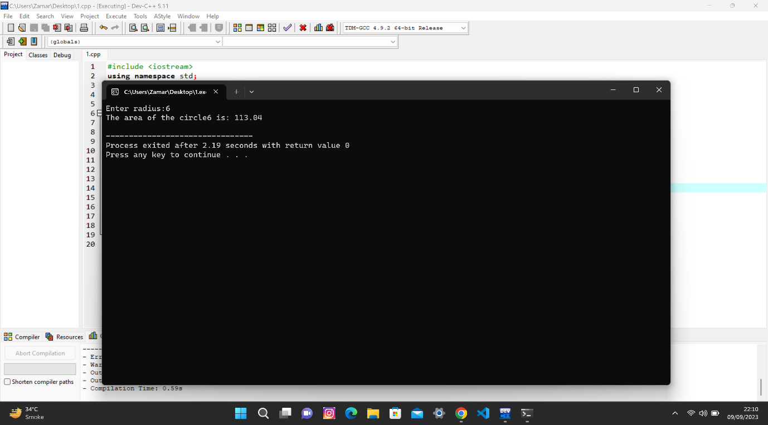

**Program 2**

#include <iostream>

using namespace std;

int main() {

float len, hei;

cout << "Enter the length:";

cin >> len;

cout << "Enter the height:";

cin >> hei;

float* ptrl = &len;

float* ptrh = &hei;

double area = 0.5 * (*ptrl) * (*ptrh);

cout << "The area of triangle:" << area << endl;

return 0;

}

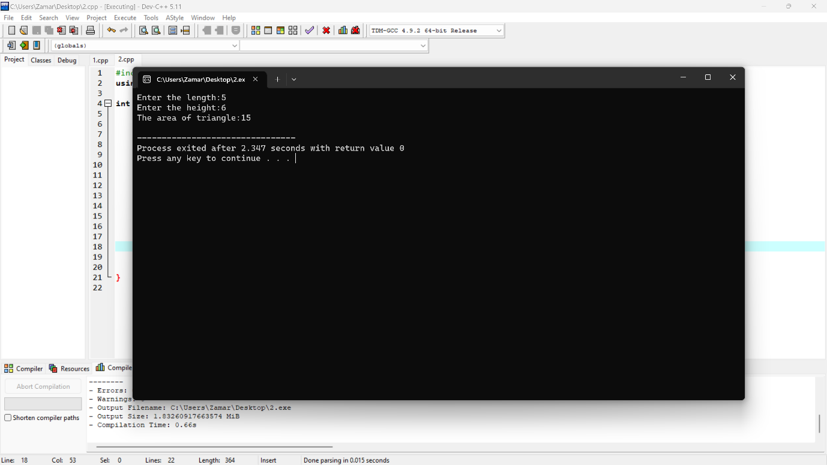

**Program 3**

#include <iostream>

using namespace std;

int main() {

float len;

cout << "Enter the length:";

cin >> len;

float* ptrl = &len;

double area = (*ptrl) * (*ptrl);

cout << "The area is "<< area << endl;

return 0;

}

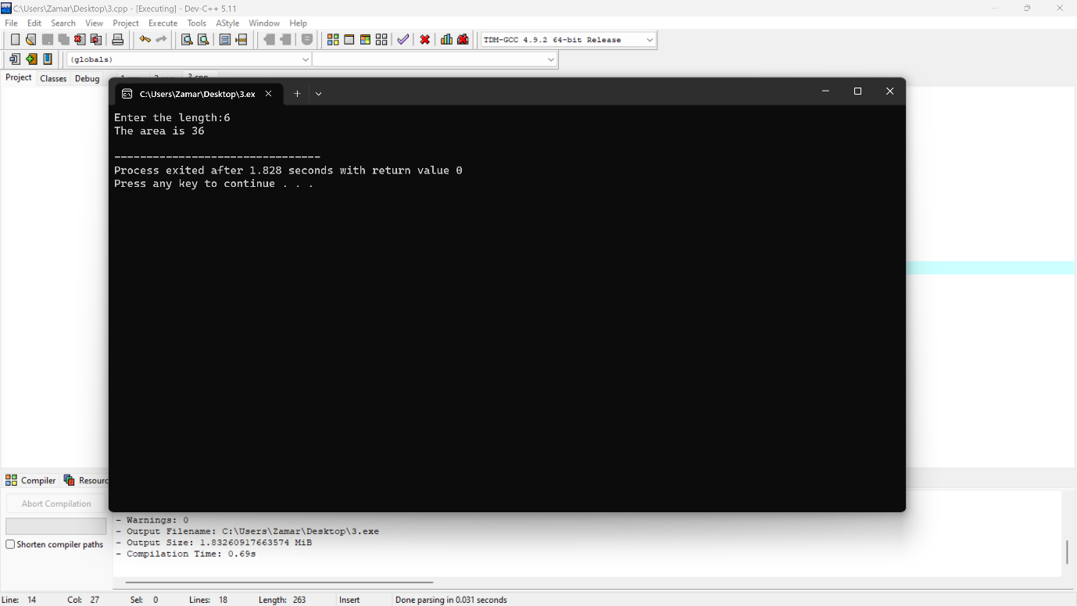

**Program 4**

#include <iostream>

using namespace std;

int main() {

int n1, n2;

cout << "Enter the first number:";

cin >> n1;

cout << "Enter the second number:";

cin >> n2;

int* ptrn1 = &n1;

int* ptrn2 = &n2;

int sum = (*ptrn1) + (*ptrn2);

cout << "Sum = " << sum << endl;

return 0;

}

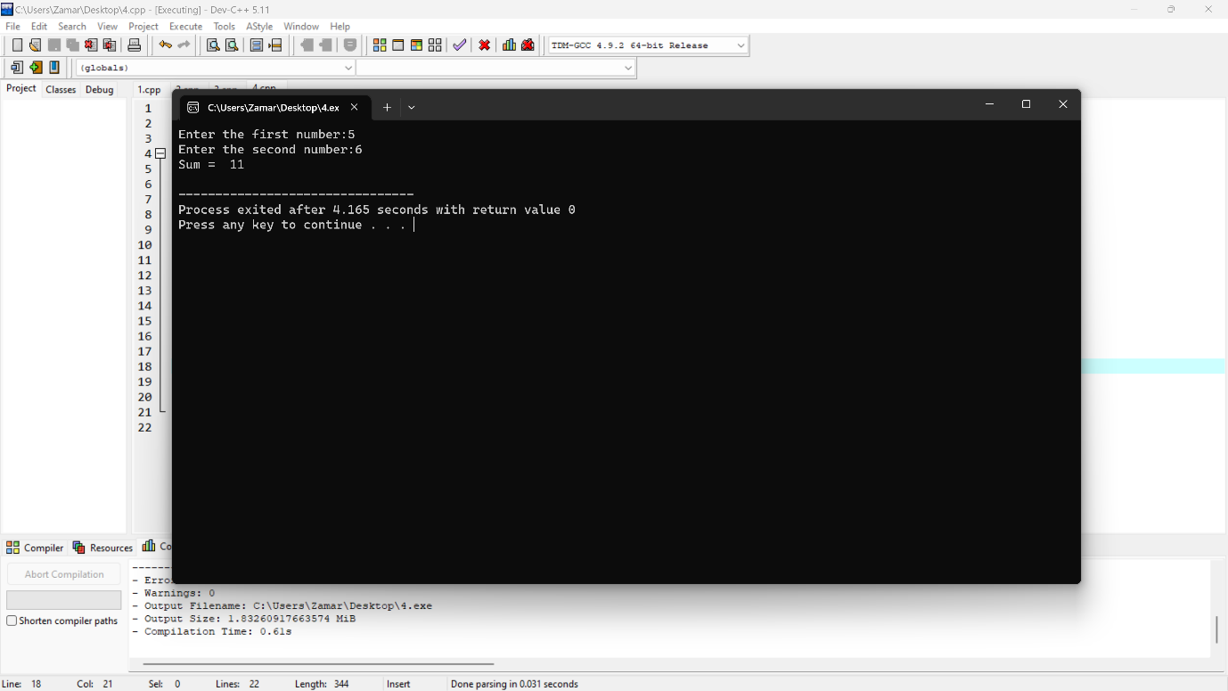

**Program 5**

#include <iostream>

using namespace std;

int main() {

float n1, n2, n3;

cout << "Enter the first number:";

cin >> n1;

cout << "Enter the second number:";

cin >> n2;

cout << "Enter the third number:";

cin >> n3;

float* ptrn1 = &n1;

float* ptrn2 = &n2;

float* ptrn3 = &n3;

float sum = (*ptrn1) + (*ptrn2) + (*ptrn3);

cout << "Sum = "<< sum << endl;

return 0;

}

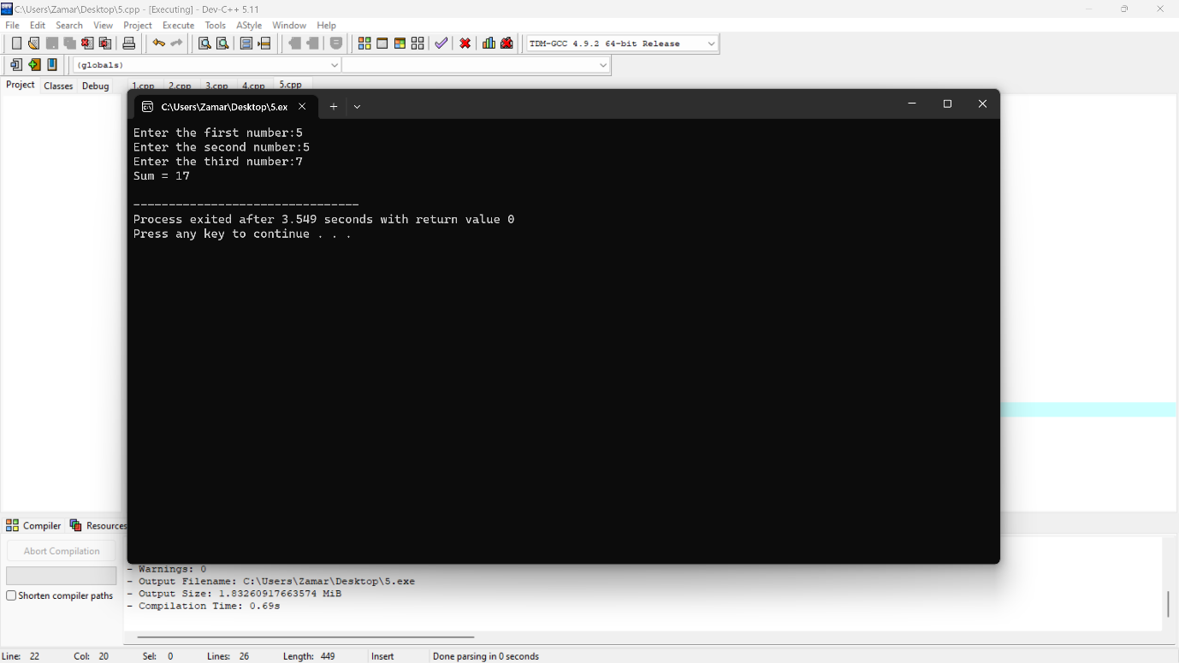

**Program 6**

#include <iostream>

using namespace std;

int main() {

int n1, n2;

cout << "Enter the first number: ";

cin >> n1;

cout << "Enter the second number: ";

cin >> n2;

int* ptr1 = &n1;

int* ptr2 = &n2;

int product = (*ptr1) * (*ptr2);

cout << "Product = "<< product << endl;

return 0;

}

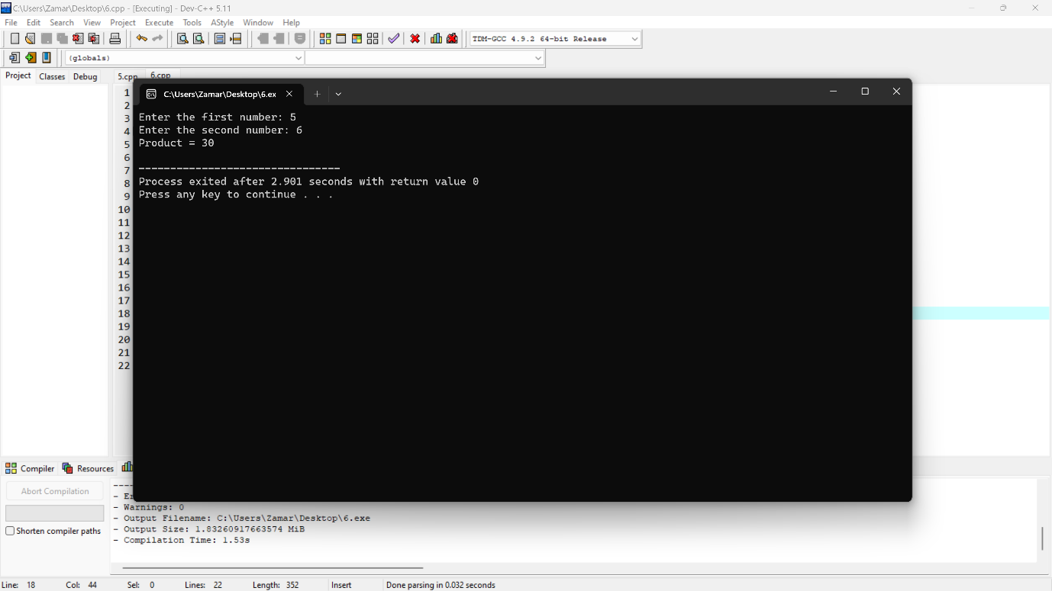

**Program 7**

#include <iostream>

using namespace std;

int main() {

float n1, n2, n3;

cout << "Enter the first number:";

cin >> n1;

cout << "Enter the second number:";

cin >> n2;

cout << "Enter the third number:";

cin >> n3;

float* ptr1 = &n1;

float* ptr2 = &n2;

float* ptr3 = &n3;

float product = (*ptr1) * (*ptr2) * (*ptr3);

cout << "Product = "<< product << endl;

return 0;

}

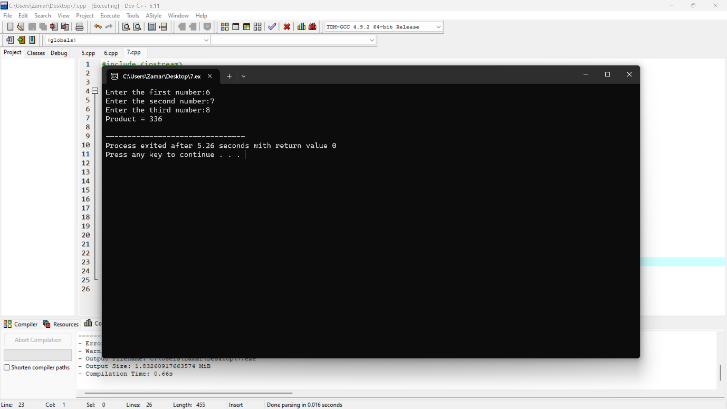

**Program 8**

#include <iostream>

using namespace std;

int main() {

float n1, n2;

cout << "Enter first number:";

cin >> n1;

cout << "Enter second number:";

cin >> n2;

if (n2 == 0) {

cout << "Error: Division by zero is not allowed." << endl;

return 1;

}

float* ptr1 = &n1;

float* ptr2 = &n2;

float ans = (*ptr1) / (*ptr2);

cout << "Answer = "<< ans << endl;

return 0;

}

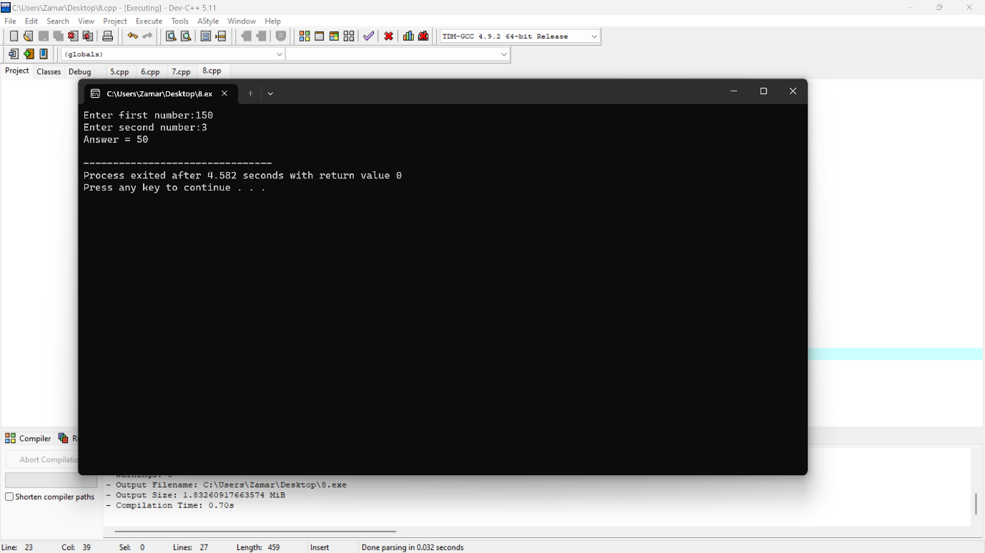

**Program 9**

#include <iostream>

using namespace std;

int main() {

float n1, n2;

cout << "Enter the first number:";

cin >> n1;

cout << "Enter the second number:";

cin >> n2;

float* ptr1 = &n1;

float* ptr2 = &n2;

float ans = (*ptr1) - (*ptr2);

cout << "Answer = "<< ans << endl;

return 0;

}

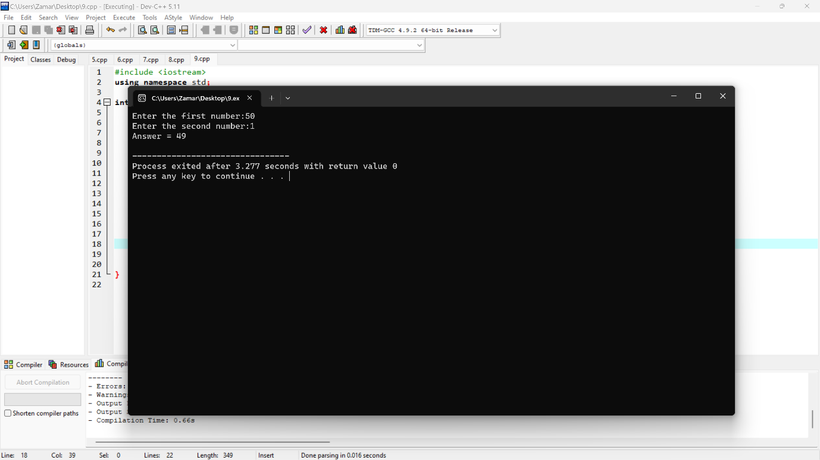

**Program 10**

#include <iostream>

using namespace std;

int main() {

int arr[6] = {1, 5, 3, 7, 5, 8};

int *ptr = arr;

int len = 0;

while (*ptr != arr[6]) {

len++;

ptr++;

}

cout << "The length of the array is: " << len << endl;

return 0;

}

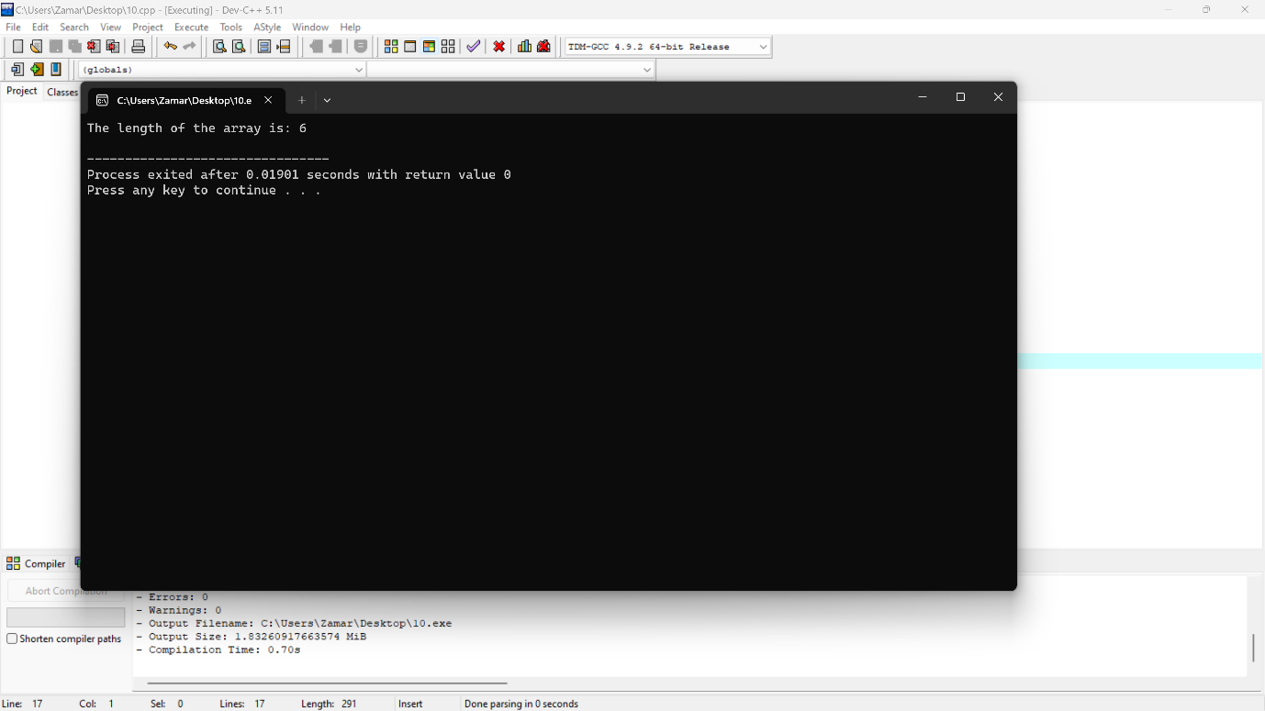

**Program 11**

#include <iostream>

using namespace std;

int main() {

int n;

cout << "Enter the number:";

cin >> n;

int* ptr = &n;

int len = 0;

while (*ptr != 0) {

len++;

*ptr /= 10;

}

cout << "The length of the number = "<< len << endl;

return 0;

}

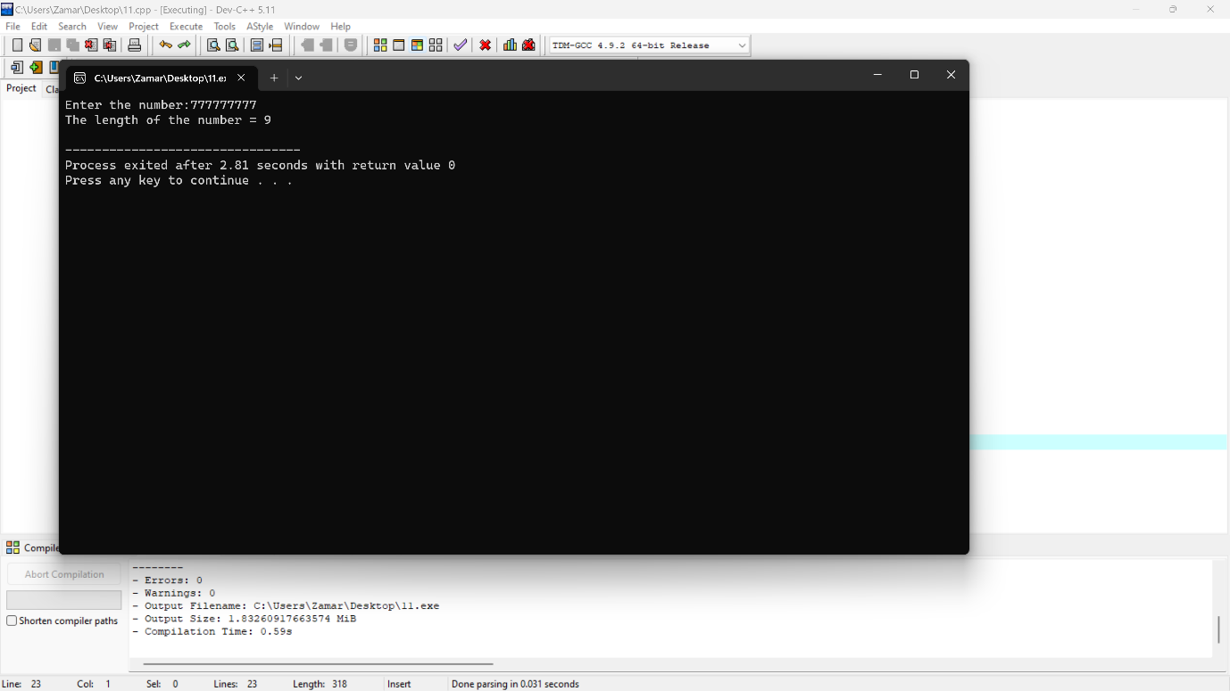

**Program 12**

#include <iostream>

using namespace std;

int main() {

int n[100];

int *ptr = n;

for (int i = 1; i <= 100; i++) {

*ptr = i;

ptr++;

}

ptr = n;

for (int i = 0; i < 100; i++) {

cout << *ptr << " ";

ptr++;

}

cout << endl;

return 0;

}

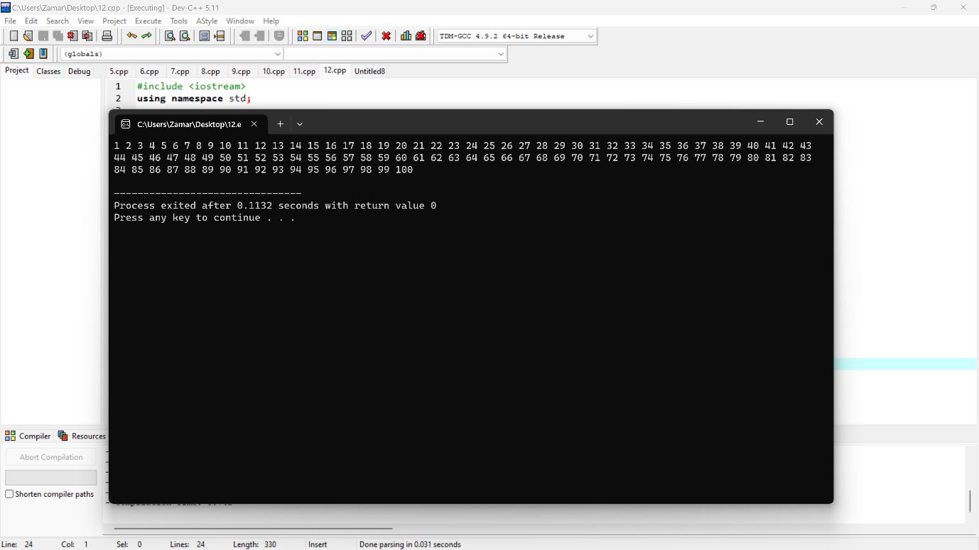

**Program 13**

#include <iostream>

using namespace std;

int main() {

int n;

cout << "Enter the number:";

cin >> n;

int *ptr = &n;

for (int i = 1; i <= 10; i++) {

cout << *ptr << " x " << i << " = " << (*ptr) * i << endl;

}

return 0;

}

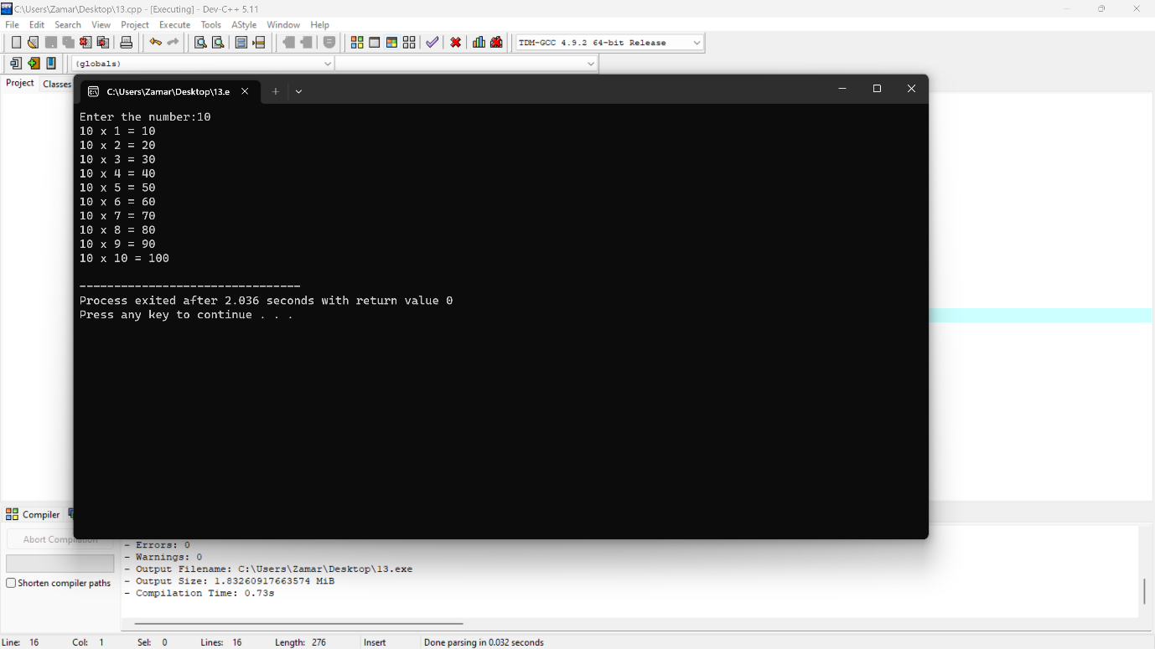

**Program 14**

#include <iostream>

using namespace std;

int main() {

int n, a = 0, b;

cout << "Enter a number: ";

cin >> n;

b = n;

while (n > 0) {

int res = n % 10;

a = (a * 10) + res;

n /= 10;

}

cout << "The number " << a << " is in reverse order." << endl;

return 0;

}

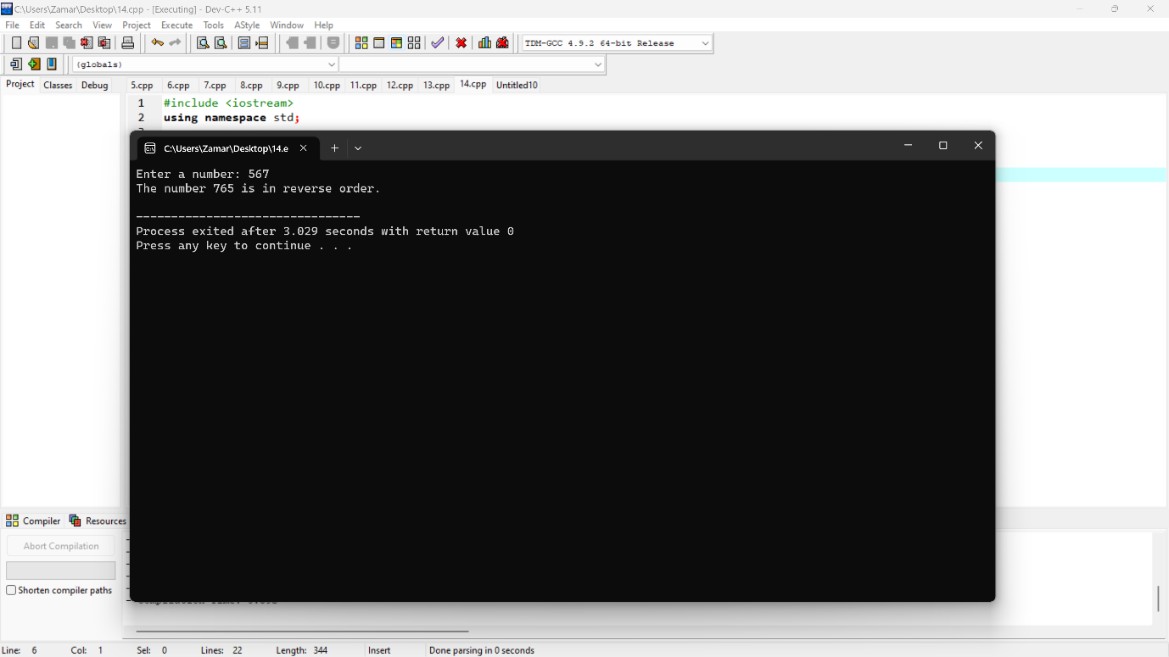

**Program 15**

#include <iostream>

using namespace std;

int main() {

int len, wth;

cout << "Enter the length:";

cin >> len;

cout << "Enter the width:";

cin >> wth;

int* ptrL = &len;

int* ptrW = &wth;

int area = (*ptrL) * (*ptrW);

cout << "The area of the rectangle = " << area << endl;

return 0;

}

